Lessons learned
Make sure the flush valves are closed before starting the engines. Pump the fuel bulb until it is firm. Check for water in the fuel filter bowl. Turn on the power switches in the port companionway tool locker.
If you just hear a click when starting the engine, it is the solenoid and the points have burned. It should still start if you try a few times. This seems to happen after about 5 years of regular use. There are several spare solenoids on the boat. Turn off the power to the engines, disconnect the 4 wires. The solenoid is press fit on 2 prongs, wiggle it off and press in the new one.
The 100 hr. oil changes are done with the vacuum extractor stored in the compartment behind the head.
The original engines were probably manufactured specifically for Seawind. They were replaced with the closest currently available engines. The electric choke, remote control attachment and steering lock were recycled from the original engines.
The engines can be lifted out using a block and tackle attached to a strop around the boom. Remove the power and control cables. Remove the shift and throttle cables. Remove the 2 bolts attaching the motor to the mount with a 1/2 “ wrench and socket set. Use duct tape and a security line to attach the wrench to the bolt head while removing the nut. Remove the recoil starter and attach the lifting fixture in its place. Use the block and tackle to lift the engine, tilting a bit to get the propeller through.
The block and tackle can be used to lift the dingy engine on and off the motor mount by attaching it to the hole in the end of the boom.
The head shower sump pump sometimes needs to be primed. Use the stern shower hose to squirt water into the exit fitting on the port side.
The holding tank Y valve was not meant to be used under pressure and will leak around the handle when the tank is full. I removed the innards and sealed off the handle so it still turns but will not leak.
If the water pressure lags when a faucet is turned on, the accumulator tank needs to be pumped up. Turn the pump off, open a faucet, remove the clamp holding the accumulator ( a stubby flat screwdriver will pry it loose), carefully lower the accumulator and use the horn air pump to fill it, 20-30 strokes.
When leaving the boat for an extended time, turn off the pressure water pump and open a faucet to relieve the pressure. The original pump was destroyed when water seeped thru the seals and into the motor.
To flush the water tank, turn off the pressure water pump, the hose from the water tank to the pump has a connector under the stbd salon seat. Separate the hose and attach a length of hose and siphon the water out the stern.
UV will degrade the Velcro and zippers so keep the covers on the Velcro pieces. The loops in the Bimini are meant for rolling up the sides so you can sit on deck with your head above the cabin top and still steer. Connect the ends of the stern shades to the loop to prevent the wind from flipping them up and exposing the zippers to UV.
For the aft enclosure, attach the side pieces. Then the aft pieces to the Bimini zippers. Connect the zippers of the side to the aft parts, then start the center zipper and finally connect the Velcro.
The hatch handles can lock the hatches in 2 positions, fully closed and slightly open. Make sure the use the fully closed position to keep rain out. It is easy to get the slightly open setting if you don’t pull down slightly when closing.

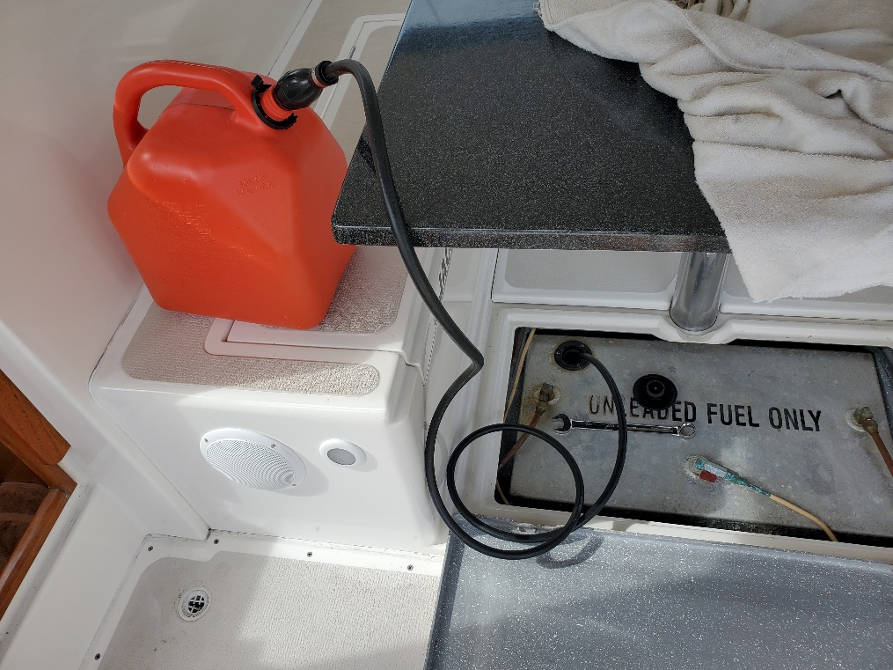
Before removing gas filler cap, loosen vent fitting ( I use the port fitting) . The wrench is kept in the stbd cabinet with the winch handles. This is a common problem, the vent line fills with gas and does not vent completely. Pressure in the vent can force the gas out of the filler and will prevent the tank from being filled.

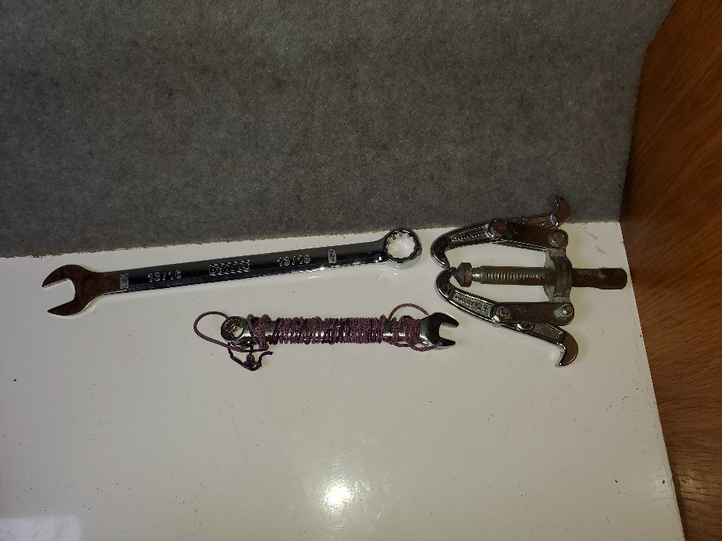

Special thinned wrench for water maker membrane connections.
Puller for steering wheel.
½” wrench for removing engine bolts

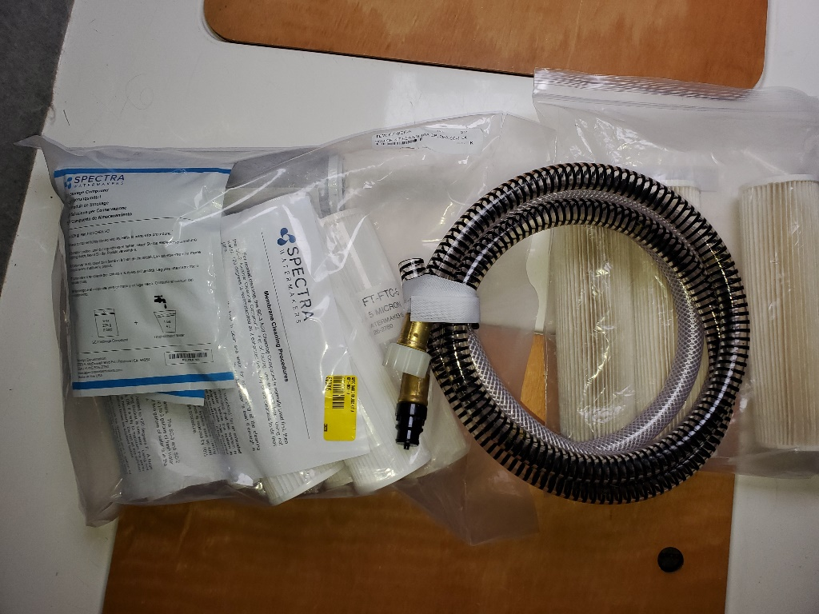

Water maker spare filters and service hoses

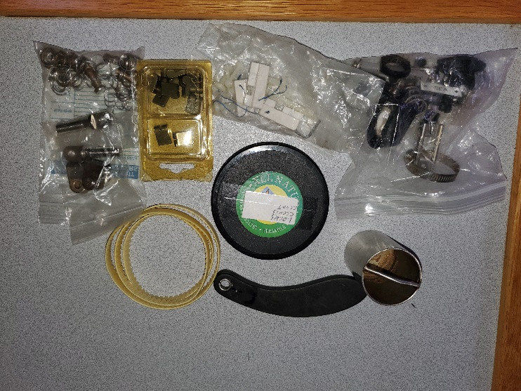
Autopilot belts
Mainsail car spares
Winch spares
Spare attachments for wind scoops
Anchor winch rope chain management system (RCMS see Muir Winch doc) works OK without it
Grease can for BBQ
Misc. spare fittings
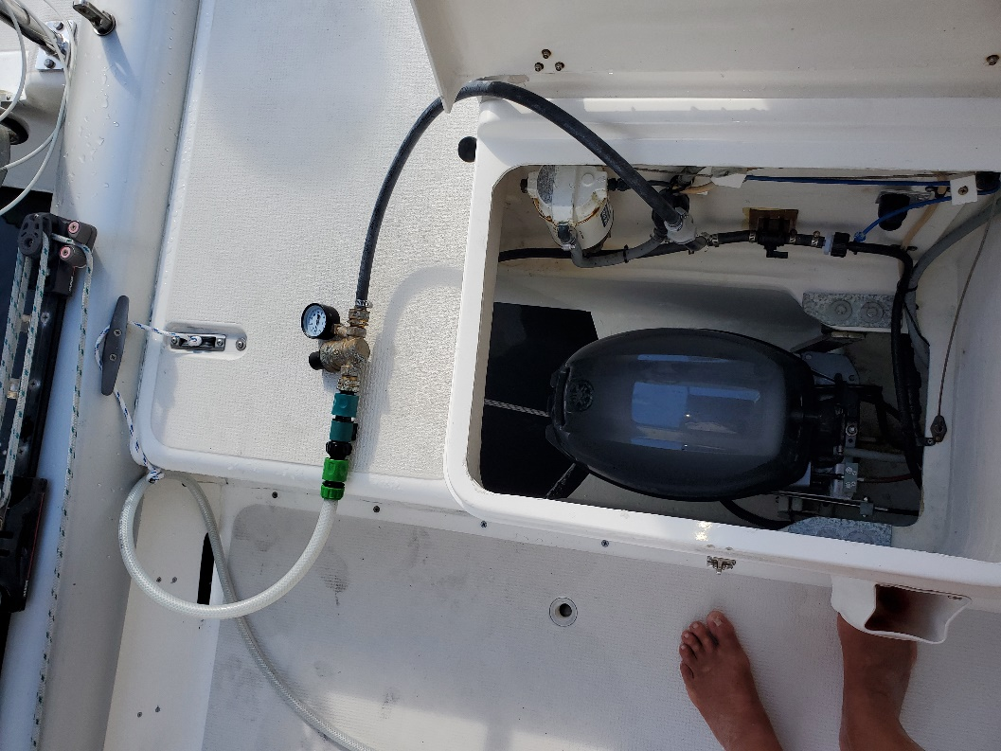

Engine flushing before shutting down or after 10 minute warmup
Attach garden hose to pressure regulator or use the stern shower attachment.
Turn engine off and turn on flush water for 5 minutes, raise engine and flush for 2 minutes. Make sure to turn off the valve
Repeat for other engine.

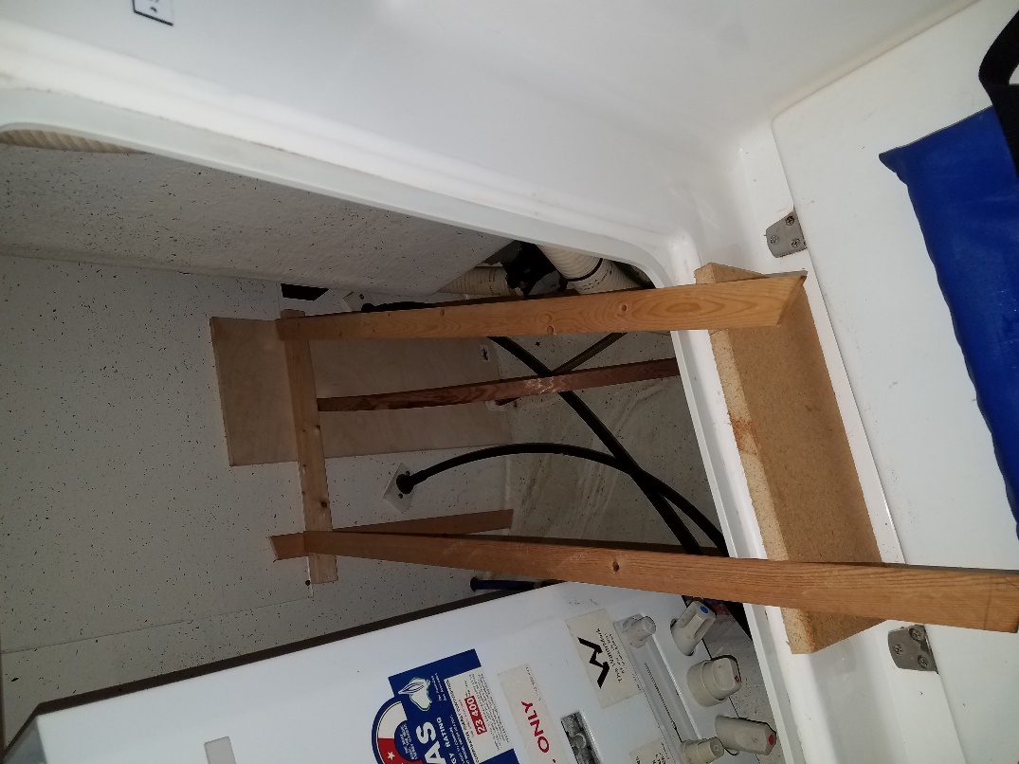

Access cradle for compartment behind head. This is the only way I can figure to access the shower sump pump and other things in the aft compartment. The components are stored underneath the owners berth.

Check the Teleflex cables at the engines, the cover starts to split after 5-10 years due to the exposure and flexing. Small splits should be OK but they will eventually grow and fail. The shift cables are exposed to salt corrosion and should be replaced when shifting becomes hard, about 5 years. I tried rubber bellows to seal out salt spray, but it did not seem to help, seemed to seal in the corrosion.
The pump assembly for the head is new, I always carried a spare. It is a fragile design, the plastic top is subject to cracking and the top screws can break off. The pump handle seal will wear after a while, there are 2 spares, do not tighten too much or the plastic top will crack.
There is a spare key hidden in the port battery compartment taped on the outboard aft corner.
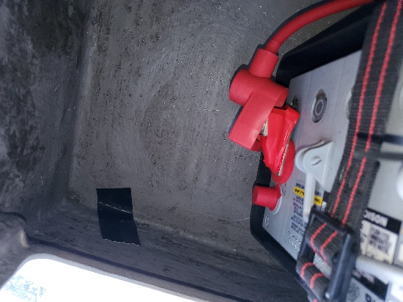

The jib halyard and furling line are both original and should probably be replaced.
The main halyard, topping lift and outhaul are only a few years old. The rest are still serviceable.

The GPS power connector can be a bit temperamental, push in and screw the cover, then push and wiggle the connector and tighten the cover and repeat a few times.

Under the stbd seat are 2 short hoses. The one with the green end is used to fill the water tank. The tank is full when water starts coming out the vent next to the water fill. The bare hose is used for cleaning the BBQ, tie the end of the dingy davit line to it and attach to the spigot on the BBQ.
The port seat has a hose used to flush the holding tank.
The stbd hatch bug screens are in holders in the locker with the garbage can. The fwd hatch screen does not fit well, you have to hold the handles and stretch it a bit to get it to latch in. The screen for the head in in the compartment below the mirror. The other screens are in brackets on the top of the compartments below the owners berth.

