The List

Table of Contents
The List 1
Imigration, Clearing In 1
Water System 1
Engines 1
Electrical 6
Safety 6
Rigging 6
Ships Papers 8
Hull 8
Dingy 11
Haulout / Refit 11

Immigration, Clearing In
Local Boater BR0145890
DTOPS Acct: B00525830
Small Vessel Reporting System (SVRS) PW: 4U$4&8FR
Call 1-877-330-7327 for reporting after return
Call 1-800-432-1216 or 1-800-451-0393 for other information
Roam gmail.com Scxica1a8hat

Water System
Water Pump service? Johnson WPS 3.4 10-13250-03 09-46779-01, 09-46782-01
Transom Shower ½ NPS-F Scandvik #10431 10’ white with 1/2 “ fittings
Handle #10279

Engines

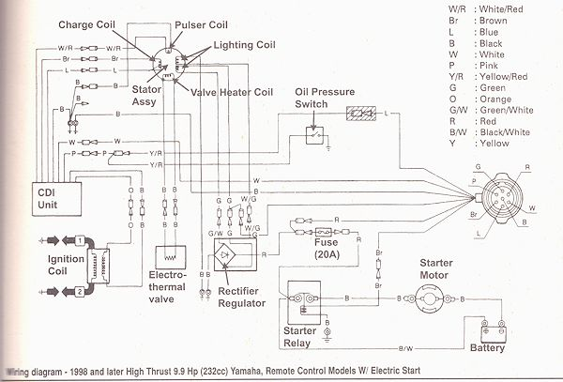
Shift FWD pushes shift link aft. Bias a bit towards reverse. Teleflex uses 5/16 wrench for nut.

Teleflex Cable Clamp 031509, Shim
TEL-031509, TEL-031538 031538 Discount Marine Source
#10 x 1 SS bolts, cut one to .815”, .7” threads for throttle cable

Fuel Level -
5 Ga 1/4 " above bottom of fill tube
10 Ga Just below chain
Engine disconnect – breaker is 64A
Fuel Hose ¼ inch

Engines used about 100 Hr before meters added
8/13/09 Stbd 156.1, Port 156.7 Replace meters after lightning strike

Engine Hours:

 | Meter |  | Trip Hrs |  | Total Hrs |  | Hrs since oil Chg |  | Hrs since impel
Date | Port | Stbd
9/1/2014 | 458 | 463 |  |  |  |  |  |  |  |  | after return from Key West, Dry Tortuga, Ft Myers
10/10/2016 | 658 | 646 | 200 | 183
11/21/2016 | 663 | 651 | 5 | 5 |  |  |  |  |  |  | Engine service Pump, Thermo, Top Anode
8/31/2017 | 708 | 704 | 45 | 53 |  |  |  |  |  |  | Return from DK
4/28/2018 | 734 | 730 | 26 | 26 |  |  |  |  |  |  | Prep for Bahama
7/4/2018 | 805 | 809 | 71 | 79 |  |  |  |  |  |  | Oil change in Abaco
7/21/2018 | 841 | 842 | 36 | 33 |  |  |  |  |  |  | Return from Abaco
10/22/2018 | 859 | 861 | 18 | 19 |  |  |  |  |  |  | Key West Oil Change
12/4/2018 | 895 | 896 | 36 | 35 |  |  |  |  |  |  | Return from Keys trip
3/25/2019 | 914 | 914 | 19 | 18 |  |  |  |  |  |  | Engine service Pump, Thermo, Top Anode, Bottom Anode
6/20/2019 | 957 | 962 | 43 | 48 |  |  |  |  |  |  | Charlestown
7/15/2019 | 998 | 1003 | 41 | 41 |  |  |  |  |  |  | St Simons Isl
 |  |  |  |  |  |  |  |  |  |  | New Engines
9/17/2019 | 1029 | 1034 | 0 | 0 | 0 | 0 | 0 | 0 | 0 | 0 | Daytona Beach New engines
9/19/2019 | 1046 | 1055 | 17 | 21 | 17 | 21 | 0 | 0 | 17 | 21 | Vero Beach initial engine oil change
12/2/2019 | 1073 | 1081 | 27 | 26 | 44 | 47 | 0 | 0 | 0 | 0 | Ft Ld engine oil and lower unit oil change
5/26/2020 | 1102 | 1108 | 29 | 27 | 73 | 74 | 29 | 27 | 29 | 27 | After Miami Trip
7/1/2020 | 1151 | 1158 | 49 | 50 | 122 | 124 | 78 | 77 | 78 | 77 | At Dry Tortuga
7/14/2020 | 1181 | 1189 | 30 | 31 | 152 | 155 | 108 | 108 | 108 | 108 | At Elliot Key
9/8/2020 | 1189 | 1192 | 8 | 3 | 160 | 158 | 116 | 111 | 116 | 111 | After Dry Tortuga Trip
9/8/2020 | 1189 | 1192 | 0 | 0 | 160 | 158 | 0 | 0 | 116 | 111 | Oil Chg
10/15/2020 | 1201.4 | 1202.8 | 12.4 | 10.8 | 172.4 | 168.8 | 12.4 | 10.8 | 128.4 | 121.8 | Return from Columbus Day, 1 wk in keys
 | 1289 | 1292 |  |  |  |  |  |  |  |  | Next oil change at
 | 1329 | 1334 |  |  |  |  |  |  |  |  | Next impeller change at

Stbd Shift Cable 7’ TFXtreme CCX63307
Shim 1” 031538 Plated Mild Steel Disc Marine $3.95
Clamp 1” 031509 Disc marine $2.95
Clamp Kit 031804 – shim, clamp, 2 bolts,nuts
F – Four Stroke
T – High Thrust
9.9
M – Manual Tilt
X – 25” shaft
R - Tiller

Control MT3
Shift Pivot 304919 WM 161671 $10.49 Mfg 031029
Throttle Connect 300646

Impeller 68T-44352-00-00 $28 63V-44352-01-00
Pump Kit 69G-W0078-00-00 ? 68T-W0078-00-00 $43 boats.net 69G replaces 68T boatpartheadquarters.com
68T-W0078-00 impeller center hole is too small PN 63V-44352-01
68G-W0078-00 has correct part, all other parts are the same
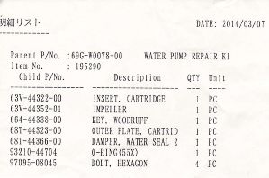

Thermostat 66M-12411-01-00 $30 Replaces 6G8-12411-03-00 marked D S60°C R
Gasket 6G8-12414-A0-00
Engine Anode 6G8-11325-00-00
Prop Anode65W-45251-00-00
Shift locknut 27 flats from locked to full down

Spark Plug BR6HS-10

Flywheel cover uses M6-20 bolts and washers
Lower unit uses M8 nuts and washers

68T-81940-00-00 STARTER RELAY ASSY $58
703-82510-43-00 MAIN SWITCH ASSY $119.55
68T-85540-00-00 C.D.I. UNIT ASSY $310
68T-81960-00-00 RECTIFIER & REGULATOR ASSY $103
680-85570-02-00 Ignition Coil Assy $105

68T-81800-00-00 6G8-81800-11-00 STARTING MOTOR ASSY $419.75

CLIP 90468-18008-00 $2.07
From T9.9XEHB-Man Starter

Engine Cable Replacement:
Remove screws from control and pedestal
Pull out a few inches of slack
Pull the controls out of the pedestal.
Remove the 2 screws that attach the 2 halves of the controls
Separate and pull Stbd half out and detach cables.
Rotate pedestal and remove cables from Port half.
Detach hose from underside of deck fitting.
Pull cables out of deck fitting.

Engine oil change
Suck out oil
On a new quart (.948mL) add oil to the 250-220 mark

Engine Maintenance
Teleflex mounts 5/15 bolt, 3/8 nut
Choke wire – pull horizontal out of keeper/pivot
Mounting bolts 5/16x3 use 1/2 “ wrench, safety string, keep on bolt with length of duct tape

Lower unit lube Marine Gearcase Lube SAE 90 80W90 40 strokes

Ignition Switch

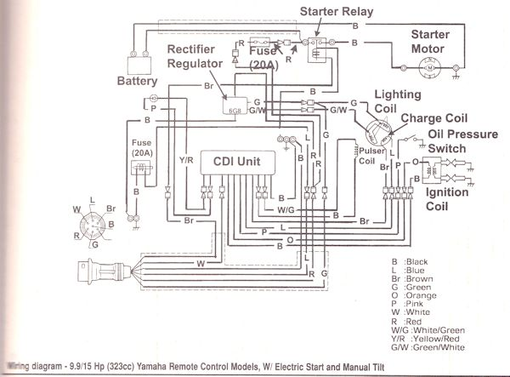

Electrical
Solar panel - old
BP3125J 125W 17.4V, 7.2A MP 22V oc, 8.1A sc

Batteries 12/15/2011 as purchased
#1 12.43v
#2 12.38v
#3 12.41v

Mast wiring colors
Anchor White single white
Steaming Orange Black
Spreader Violet White
Commons White with black stripe

Rudder sensor - Red/Green swapped at autopilot

New Galley light RGB LED
Fixture has M plug, M contacts , ground on latch side
Ceiling wiring has F plug, F contacts, ground on latch side

Bulbs:
Anchor light bulb 90400200 90400177 8.5 8.41mm festoon
ForeDeck light 90400470 ba9s halogen bayonet

GPS EchoMap 50s SW V4.8, GPS 617.10 Unit ID 3864958981
Map Us Marine Details G2 V2013 V 14.50

S/N 320002915

Safety
Life Jacket Stearns 0924 Rearming Kit 092KIT-000-00 Defender 552095
New security cable, old one is 22’

Rigging
Mainsail car part Bainbridge U00642 Toggle assembly
Main Halyard Bolt uses 3/4 “ wrench for bolt and nut
New main halyard is 12’ too long
Anchor windlass uses 6mm allen key
Anchor roller 6”, ½”shaft WM 4” delrin $43
Jib traveler end cap Trim cap – PN 1621 End stop E2700
Rigging measurements – nut to top thread
Stbd Lower 3 5/32
Port Lower 2 13/16
Forestay 2 12/32
Port 2 15/16
Stbd 3

Orig black reef line 125’
Recommended Reef1 132’, Reef2 99’
Current reef lines are 125’ (old) and 155’ (new green)

Jack lines
Aft section 25’
Next section 25’
3d section 15’
Front section ?

Old measurements:
Port
Aft section 14ft 7 in
25ft 6 in
25ft 1 in

Stbd
Aft 15
24
25ft 1 in

Boom Gooseneck tang 0.41” wide 1/8” gap between jaws and tang, 25/32 hole in boom jaws ~3/4”, bolt is ½”
Topping Lift 18” shackle to sail cover loop

Dock lines 4 @ 40'
12" finished eye size

Fid sizes Short Long Full
5/16 2.5 4.25 6.75
3/8 3 4.75 7.75

Rope clutches Port to Stbd
Jib Furl
Jib Sheet
Jib Halyard
Topping Lift
Reef 2

Clew
Reef 1
Main Halyard
Screecher Halyard
Jib Sheet

Main traveler track R32 3159
Jib traveler track R27 1602
Main sail battcar track System B 3844

Fender lines
3/8" 3 strand 6' 2" original line lengh, 5' finished length
24" whipping twine

Knot
Tape
Tape
36"
12"
5"

Ships Papers
FCC WDE4830 Exp 5/23/2018
MMSI 367358350

Hull
Rudder post cap O ring 1.4” ID, 1/8 Dia. 1.5”ID works
Tramp strut end .79” dia 20mm Grainger #18EA16 furniture leg tip ¾”

Rear seat slats
-----------------------------------------------------------------------------------------
| 1 | 6 |
| 2 | 5 |
| 3 | 4 |
| 4 | 3 |
| 5 | 2 |
| 6 | 1 |
-----------------------------------------------------------------------------------------

Shade bungies
33” length of ¼” shock cord
Original shock cord is slightly less than ¼.
New shock cord is 36”.

Wheel Nut ¾ x 10 10-8 SS Cap nut

3/5/2020 Rebed Stbd Fwd hatch with black Life Caulk
Feb 2020 Rebed Stbd Mid hatch, Port Fwd hatch with Life Caulk
Mar 2021 Rebed Port Mid hatch Life Caulk

Fwd window Velcro pieces numbering system looking forward from inside


Air Strut for opening windows
Length 316 MM
Dia 8-18
Force 150N

Window seal Grainger # 10D164 Mfg Trim Lok # X109BT-20 or 25 ft length .
Window Pull 28”

Hinge bolts replaced with #10 screws to prevent corrosion. Use #10 nylon washers and 5/16 OD, 3/16 ID polyethylene tubing to isolate SS screw from aluminum frame. ½” length for outer hinge sections, 7/8” inner section.

S
P
Port aft access

Black Single

Dingy

Dingy lift harness
Bow 28” 30”
Stern 24.5” 29”

Dingy Engine Mercury 15 Hp EFI
OR891197 1A15201BK

Spark Plug
Lube Gasket
Thermo
Thermo Gasket
Anode
Pump rebuild

Dingy engine mount 9.5 ft of 1/8 inch cord each side

Mercury 15 HP dingy motor
Model # 1A15201BK
SN OR891197
Cost: $2687.50

SERVICE MANUAL 15/20 EFI 4-Stroke
8M0125265
PARTS MANUAL 15/20 EFI/2 Cylinder/ 4-Stroke
8M0125267

FILTER Fuel
8M0134466
THERMOSTAT
8M0139434
GASKET
853702005
FILTER ASSEMBLY Oil
822626K03
IMPELLER
8M0135803
ANODE
8M0137344
GASKET Guide Plate
8M0135806
SEAL
8036674
LINER Water Pump
803751
SPARK PLUG NGK#DCPR6E
803507
IGNITION COIL
8M0134472
SENSOR Coolant Temperature
8M0135709
SWITCH Oil Pressure
803538
ECU Engine Control Unit *{ 10/15 HP/ 15 HP ProKicker}*
8M0135815

HP / kW | - 15 / 11.1
Engine type | - Inline 2
Displacement (CID/CC) | - 20.3 / 333
Full throttle RPM | - 5700 - 6200
Fuel induction system | - 2 valves per cylinder, single overhead cam (SOHC)
Alternator amp / Watt | - 12/145 electric
Recommended fuel | - 87% octane / up to 10% ethanol
Recommended oil | - 25W-40 Synthetic Blend  - Mercury FC-W 10W-30 4-Stroke Marine Oil
Engine protection operator warning system | - Low oil pressure  - Low water pressure  - Over-rev  - Overheat  - Sensor failure
Starting | - Electric  - Manual
Steering | - Remote  - Tiller
Shaft length | - 15" / 381 mm  - 20" / 508 mm  - 25" / 635 mm
Gearcase ratio | - 2.15:1
Dry weight *Lightest model available | - 99 lbs / 45 kg
CARB star rating | - 3
Bore and stroke | - 2.40 x 2.24" / 61 x 57 mm
Ignition | - CDI w/electronic spark advance
Fuel system | - Electronic Fuel Injection (EFI)
Cooling system | - Water-cooled with thermostat
Gear shift | - F-N-R
Gearcase options | - Standard
Trim system | - Manual  - Power Tilt
Trim positions | - 6
Exhaust system | - Through prop
Shallow water drive | - Yes
Shallow water trim range (degrees) | - 16
Remote fuel tank (optional) | - Yes
Remote fuel tank standard (gal / L) | - 6.6 / 25
Color | - Phantom Black

Haulout / Refit

3/30/13 Refit

Tramp Pole ends 13/16 pole diameter, 7/8 leg tips too big

Bumper for fuel door, anchor locker Size ________________

Stereo cable m-m minijack

Anchor roller 6”, ½”shaft WM 4” delrin $43

Air freshener

RIB, 18” clearance and bench back, 33 at bottom bracket, 36 at cross tube

Change engine oil

New security cable, old one is 22’

Boom extension for motor lift, 2’ extra OK, 3’ optimal

Gear pouch 2 x 10x36 wide, 2 x 10x12 wide

Line holders

OB handle extension Size_______________

Replace motor cleats Type _______________ Measure ____________________

Jib traveler end cap Trim cap – PN 1621 End stop E2700

SS ½” wrench x2

-----------------------
Mattress - Resew cover thicker or get thin foam

Fresh Water Flush

Port Covers

Calibrate compass – use adjustment at right angles to N

Autopilot calibrate

Water Pump service? Johnson WPS 3.4 10-13250-03 09-46779-01, 09-46782-01

VHF lightning arrester

Connect GPS to PC

Auger Anchors

Reseal mast feedthrough

Circuit breaker compartment leak

Anchor chain marking
Almost up
50', 70', 90',110', 130'

Windless counter sensor

Engine spares

Head spares

Hatch spares

Stbd Overhead panel support

Paint slats

Soft Hatch cover w insect screen, detachable?
One cover and one screen?

Plug in fan

Bench for Head compartment

Hose Clamp Ends

Elect Choke O ring

Organize VHF locker, holders, shelves, wire clamps

Shelfs for stbd aft lockers with shelf liner

lube window bolts

1/2 to 1/4 socket converter

Fuel filter Sierra 18-7919S

Hour Meter connection
Black

Red
Paint cabin trim pieces

Shelf in kitchen

Radio antenna splitter or extension

Inside Hatch Handle

Curtain slides?

Electronic copies of manuals

Alarm Buzzer 20 Ga duplex wire

Hour meter still functioning? 8/13/09 Stbd 156.1, Port 156.7

Dock Cleats

Cover for anchor cleat

Door latch - measure/cut holder for both sides

2 more LED lights, Intensity switches

Power connector for lights, radio, etc ~10A

Davit support - Measure, end pieces

Dingy motor

New windscoop attachments

Enclosure stitching

Main cabin light - Order more light strips

Trash lid latch

Head Y Valve

Compass Lights

Mast light fuse panel

Stereo disconnect – pull plug

Swim ladder broken bolt Size ¼ x 5/8, a little long

Program MSSI# in VHF

Connect GPS to VHF

Connect GPS to AP

Autopilot disconnect

Zero shunt

Measure light currents
At 13.2v
Fan Lo .243, .252
Fan Hi .49, .517
Red festoon .032
6 White .754, .716
2 White .271
Incandescent .354
Fluorescent .77
G4 LED .129

Replace AP display

Reseal inst panel

Clean/Wax sliding doors

Ground solar regulator box ? OK to ground, 12"

Ground wire 22” inside, 32” outside for 55” total length

